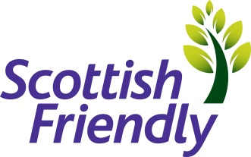

Title : | Quality Assurance Coordinator
Employment Type: | Permanent and Fixed term Contracts
Department : | Customer Experience
Location | Glasgow
Closing Date | 20/05/22
Recruiter | Angela Higgins, please send covering letter and  CV to angela.higgins@scottishfriendly.co.uk

At Scottish Friendly we want to attract the best talent to help us achieve our vision: to be a leading UK mutual insurer through innovation, efficient customer services and responsible capital management. Scottish Friendly is one of the most progressive mutual life insurance offices in the UK with over 150 years’ worth of history in the financial services market. Based in Glasgow, Scottish Friendly is a dynamic and rapidly expanding financial services group dedicated to the efficient provision of a wide range of financial products and services. We employ circa 240 staff and are growing.

As a friendly society, we don’t have any shareholders, so all profits are used for the benefit of the customers. Our people are enthusiastic and passionate about saving and investing.
If you’re inspired to join us, and have the necessary qualities, then this could be the opportunity you’ve been looking for.
The role:
Opportunities have arisen within our Customer Experience team; we are looking for candidates that have experience within Financial Services and Investments who have meticulous attention to detail and a passion for improvement.
Key Responsibilities:
- Keeping our customer journey at the heart of every process
- Reviewing customer service delivery processes and ensuring they meet required and documented standards
- Testing key controls within our customer delivery processes and ensure they are being operated as designed and are delivering the desired customer outcomes
- Identifying and recommending process and control improvements to help drive quality
- Performing trend analysis and reporting to management
You will have:
- Life, Pension, and investment knowledge
- Experience in, and be comfortable with, reviewing and checking the work of other colleagues
- A desire to help drive improvement and deliver great outcomes for SF`s customers
- Confidence to engage with a variety of stakeholders, including CS team leaders and managers
- Strong attention to detail and focus on accuracy
- Excellent communication skills – both written and verbal
- Comfortable challenging and enhancing current processes as well as develop new processes
- Ability to examine information or a situation in detail identifying key information
We are an equal opportunities employer, we believe diversity brings benefits for our customers, our business and our people. We welcome applications from all individuals and will consider flexible working arrangements for any of our roles.

