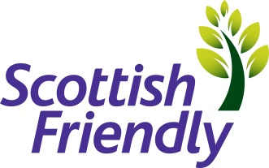

Title : | Claims Customer Service Administrator
Employment Type: | Permanent
Department : | Customer Service
Location | Glasgow
Closing Date | 20/05/22
Recruiter | Angela Higgins, please send covering letter and  CV to angela.higgins@scottishfriendly.co.uk

At Scottish Friendly we want to attract the best talent to help us achieve our vision: to be a leading UK mutual insurer through innovation, efficient customer services and responsible capital management. Scottish Friendly is one of the most progressive mutual life insurance offices in the UK with over 150 years’ worth of history in the financial services market. Based in Glasgow, Scottish Friendly is a dynamic and rapidly expanding financial services group dedicated to the efficient provision of a wide range of financial products and services. We employ circa 240 staff and are growing.

As a friendly society, we don’t have any shareholders, so all profits are used for the benefit of the customers. Our people are enthusiastic and passionate about saving and investing.
If you’re inspired to join us, and have the necessary qualities, then this could be the opportunity you’ve been looking for.
The role:
Opportunities have arisen within our Customer Services team; we are looking for candidates that have experience within Financial Services and Investments who have meticulous attention to detail with experience in processing life claims.
Key Responsibilities:
- Processing of maturities, surrenders and deaths for all books of business including Partnership claims
- Accuracy and attention to detail
- Ensuring claims are completed in a timely manner and within the agreed SLA
- Engaging with customers throughout the claim process
- Applying empathy and understanding to customers throughout the death claim process
- Always ensure the highest standard of customer service
- To ensure a high precision level in the maintenance of all relevant computer systems and excel spreadsheets
- To ensure procedures are adhered to and kept up to date.
- To have a good knowledge of products with the ability to read & understand product specifications & T&C’s
You will have:
- Experience in processing claims
- Attention to detail with ability to complete work to a high standard.
- Effective communication skills – both verbal and written.
- Ability to work as part of a team and on your own
- Accurate numerical skills with the ability to check claim values
We are an equal opportunities employer, we believe diversity brings benefits for our customers, our business and our people. We welcome applications from all individuals and will consider flexible working arrangements for any of our roles.

